**Nivea’s popularity and competition:**

**WHEN TO ADVERTISE?**

This plot helps to identify a seasonal trend each year, it indicates that web searches tend to increase steadily from Jan to May, sometimes to July. Thereafter plunging down until October and gaining back its momentum peaking in November or December.

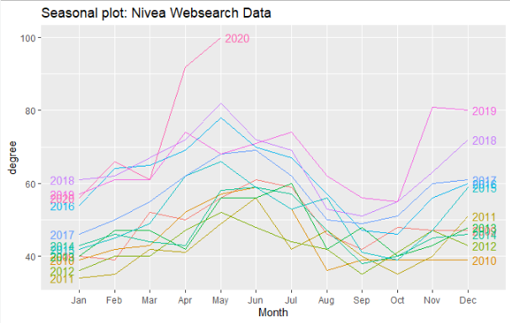

Here is the same plot using different visualization graph:

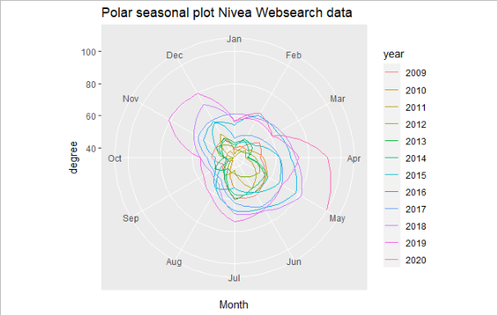

These graphs provide a general guideline as to when to launch or advertise Nivea’s products to take advantage of the web search seasonality. It seems that Jan and Oct are the best time to do so.

QUESTION TO NIVEA: has there been any tradition of advertising at the beginning of the year or on October because we notice a pattern in web searches? If the answer is no, it means that the pattern reveals a seasonality of consumers’ behavior.

**WHERE TO ADVERTISE?**

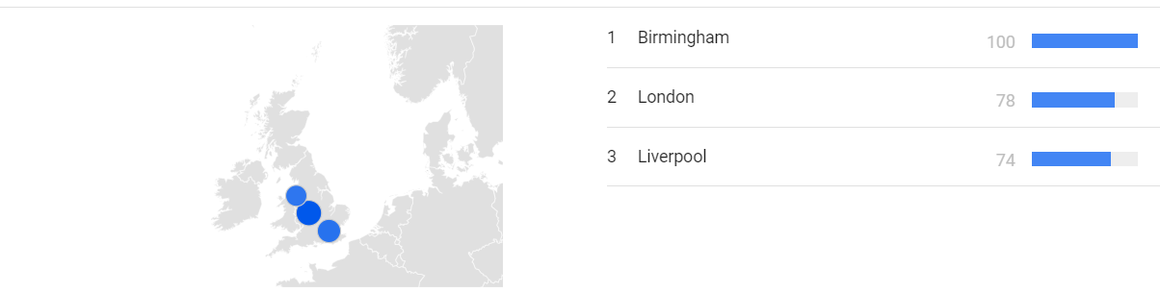

Based on the most searches all around the United Kingdom in the past 12months, Nivea seems to be the most popular in Birmingham, followed by London and Liverpool respectively, therefore these three are the most desirable places to advertise or launch new products.

**WHO ARE NIVEA’S COMPETITORS:**

According to SWOT analysis, Vaseline and Ponds are the two main competitors of Nivea.

First, we will analyze the online shopping behavior of consumers of the three companies, the data is collected by filtering out normal web searches by selecting “Google Shopping” in google.com/trends/. The raw data as shown below is extremely noisy, which makes it difficult to identify the pattern and the leader of online shopping.

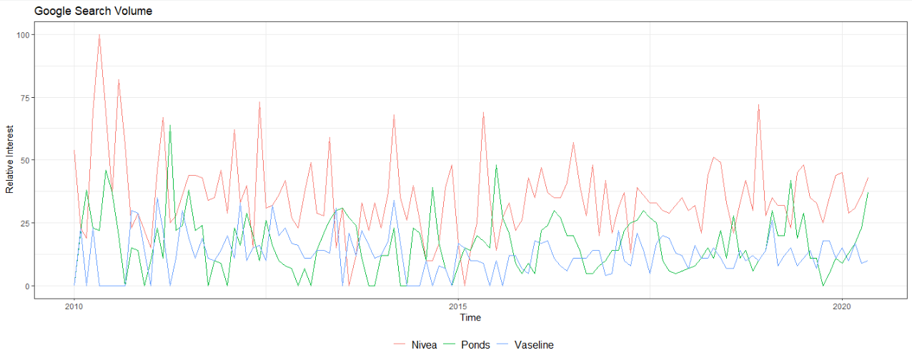

QUESTION: In May 2010, there is a big spike in online shopping for Nivea, were you aware of this? If yes, do you know what caused it?

To get a better gasp on the trend of the graphs, we are applying the exponential smoothing to it in R. As seen below, the exponential smoothing provides a more comprehensive view of the trends. It now clearly displays the superiority of Nivea in terms of online shopping. Ponds seem to have a larger amount of market share than Vaseline but visually, there is a positive correlation between the former and Nivea. However, Vaseline is negatively correlated to Nivea, which could suggest that one company succeed to the detriment of the other to a small extent. Therefore, it is more important to compete against Vaseline than Ponds in terms of online shopping, despite Ponds’ superior market share.

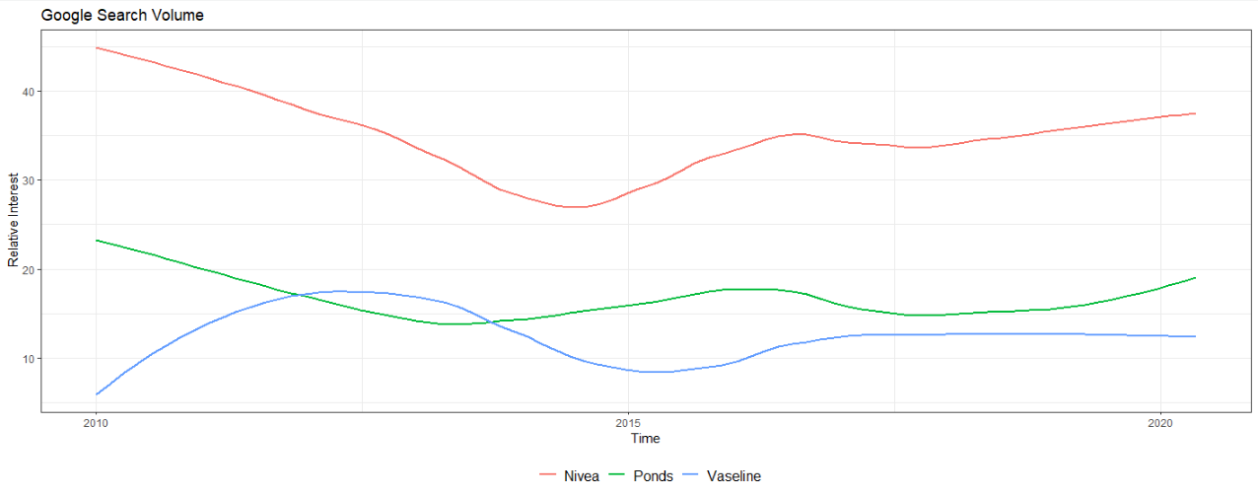

Now let us analyze the web searches in general between competitors, as seen below, it seems to suggest that Ponds is the market leader. However, Ponds’ searches are extremely volatile, its peaks far exceed its peers, however, its troughs also fall below others.

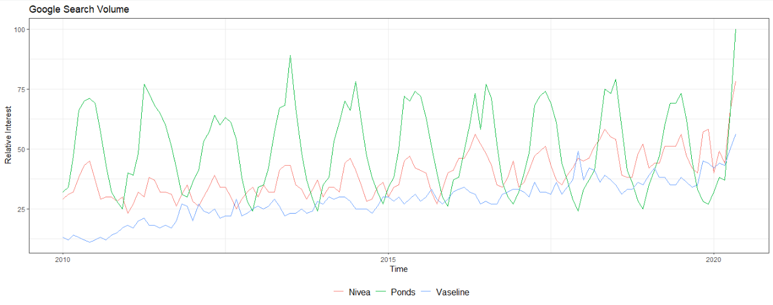

Despite inferences made on the above graph, it is too noisy to draw any reliable conclusion, therefore, we will also apply an exponential smoothing to the plot. It is now clear that Ponds used to be the market leader in terms of web searches, however, it has struggled to grow interests among internet users. In fact, its online traffic has been on the downtrend since 2018.

On the other hand, Nivea and Vaseline traffics have been at constant rise. This fact confirms our previous conclusion, suggesting that is worth keeping an eye on compared to Ponds.

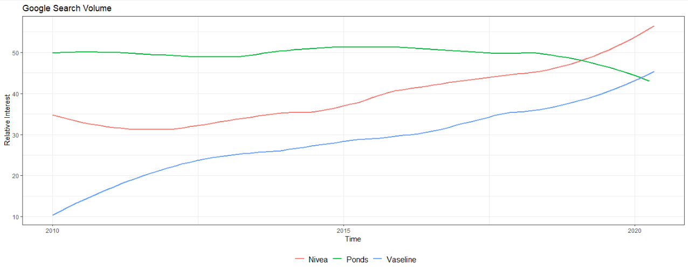

**FORECASTING NIVEA GROWTH (THIS PART IS NOT IMPORTANT):**

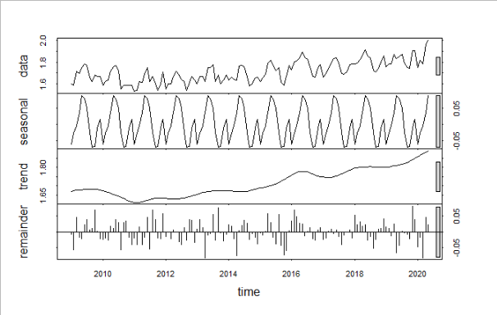

A series of mathematical formulas have been applied to break down the raw data into “seasonal”, “general trend” and “remainder”, which could also be understood as random fluctuations. The result suggests a general trend of a steady increase of web searches throughout in the last 10 years.

Although we visually deduced a seasonal trend in the previous part, mathematically, the trend is not regular enough to reliably forecast the future (as indicated long bar on the far right of “seasonal” plot).

Therefore, we are using an Auto Regressive Integrated Moving Average to predict the next 12months searches for Nivea. The blue line is the prediction, while the orange lines indicate the interval of certainty of 95%.

